
USER INTERFACEDESIGN
23CSE113LAB
MANUAL
NAME | HARSHA VARDHAN
ROLL NO. | AV.SC.U4CSE25228
YEAR/SEM/SEC | 1st-YEAR/ SEM-2/ CSE-C
C REDITS | 03

SUBMITTED TO | DR. RAJ KUMAR BATCHU
DESIGNATION | ASST.PROFFESSOR (Sl. Grade)
DEPARTMENT | SCHOOL OF COMPUTING

S.NO | TITLE | PAGE NO. | REMARKS
 | WEEK1  1.INSTALLATION OF VSCODE  2.UNDERSTANDING BASICS OF HTML  3.UNDERSTANDING BASIC HTML TAGS | 3-8  9  10
 | WEEK2  1.Create the class time table using HTML elements  2.Create an HTML webpage that should display syllabus of all the subjects of an image format also time table | 14-19  20-22

WEEK1
AIM: STEPS TO INSTALL VSCODE
PROCEDURE
STEP1:
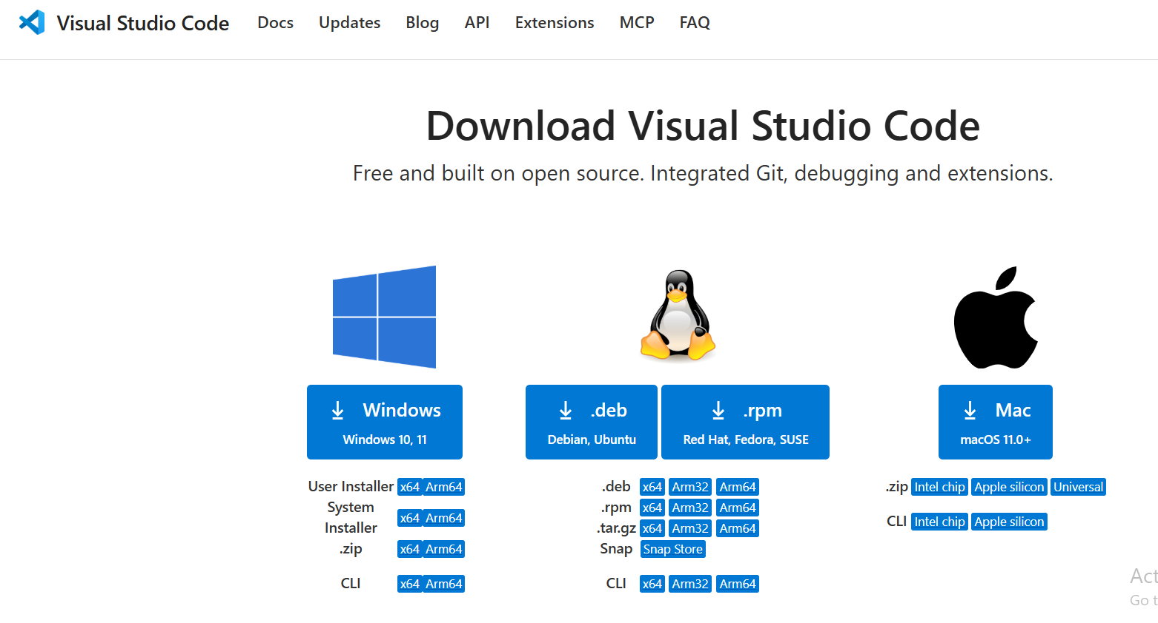

STEP2: 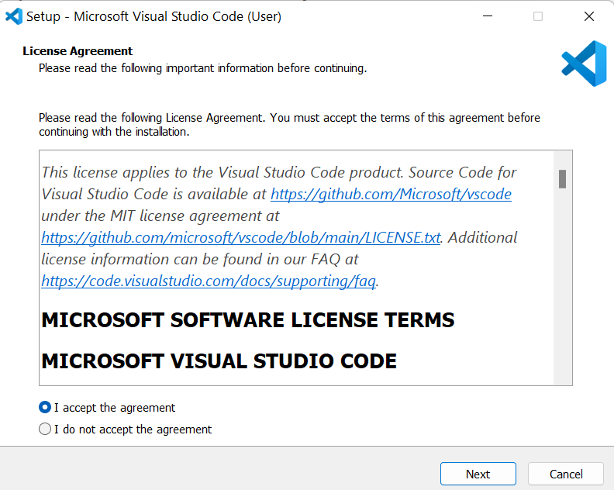

STEP3: 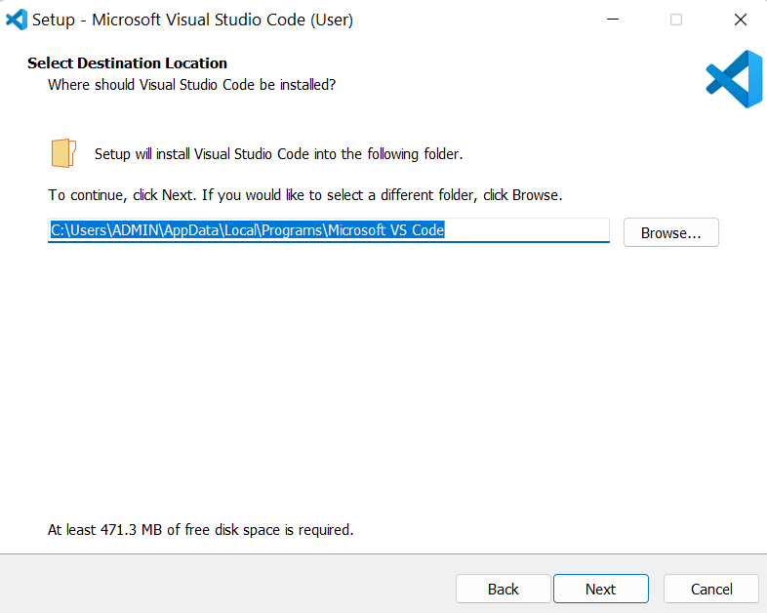
STEP4:
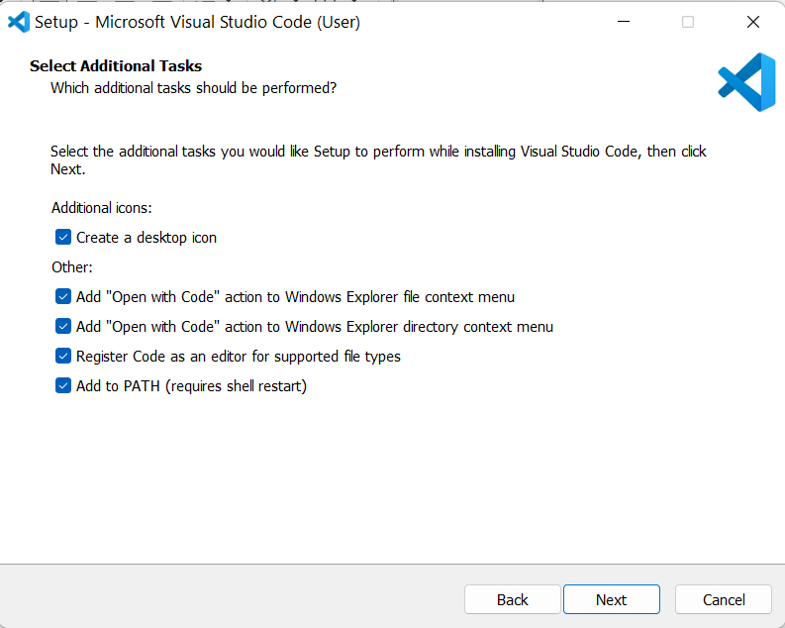
STEP5: 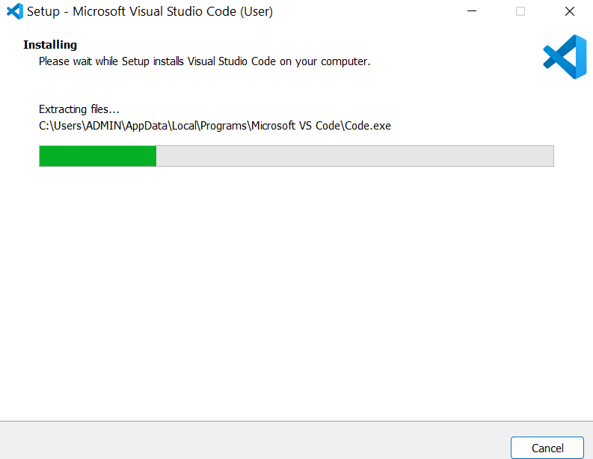

STEP6: 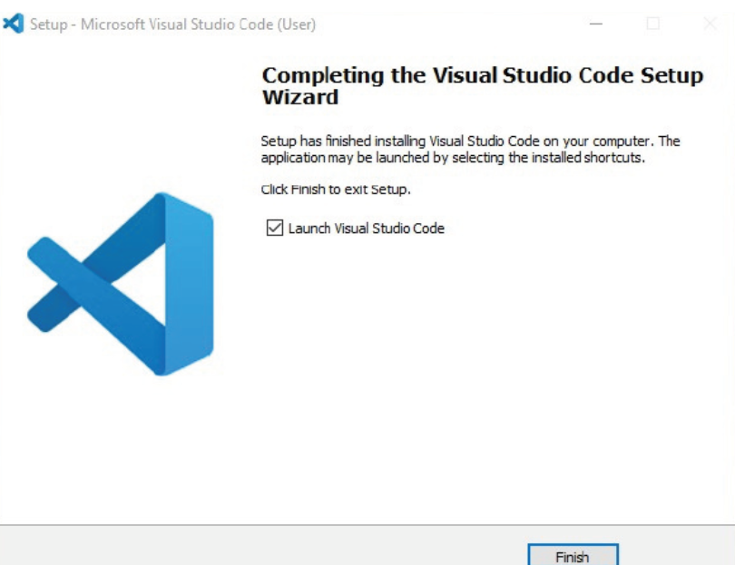

AIM: TO LEARN BASICS OF HTML
PROGRAM:

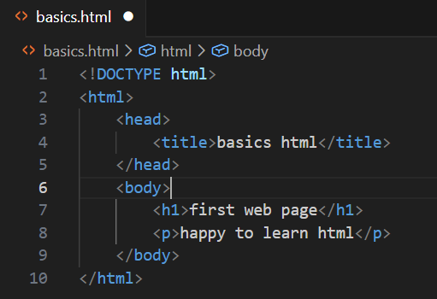

OUTPUT:

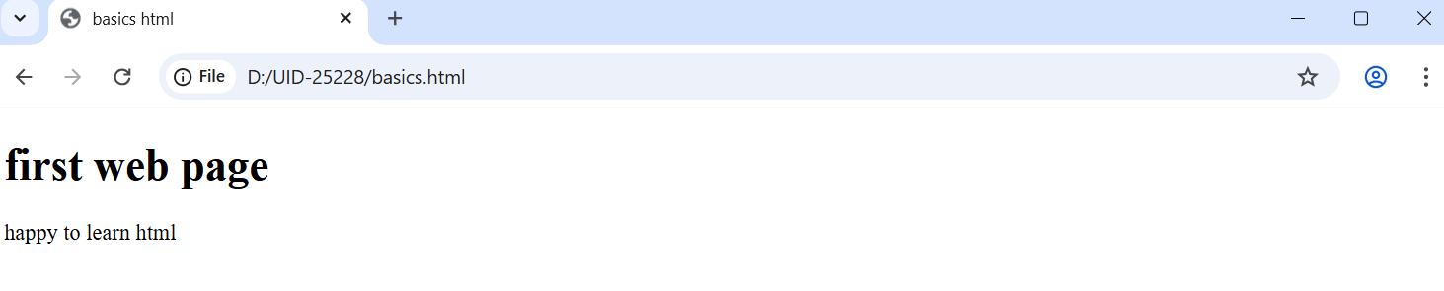
Explanation of basic html tags:

HTML stands for Hyper Text Markup Language.
HTML is used to create and structure web pages.
It tells the web browser what to display and how to display it.

<DOCTYPE HTML> : The <DOCTYPE html>element tells the browser , this is an HTML5 document
<html>: The <html> element is the root element of an HTML page.
<head>: The <head> element contains meta information about the HTML page.
<title>: The <title> element specifies a title for the HTML page.
<body>: The <body>element contains all visible content like text ,images ,links ,tables ,etc.
<h3>: The <h3> element defines a large heading.
<p>: The <p> element defines a paragraph.

3. Aim : understanding basic html tags.
Tags - <p>; <h1>;<img>;<color>;
Program:

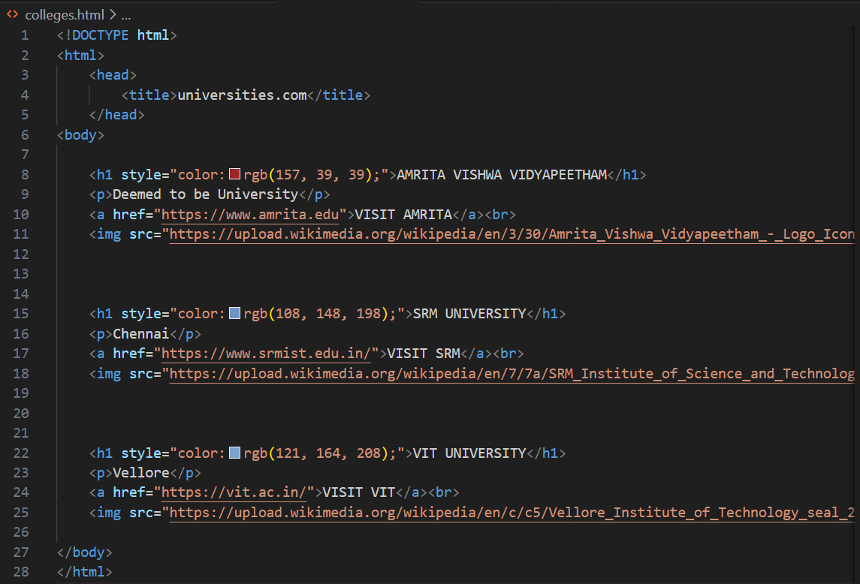

OUTPUT:

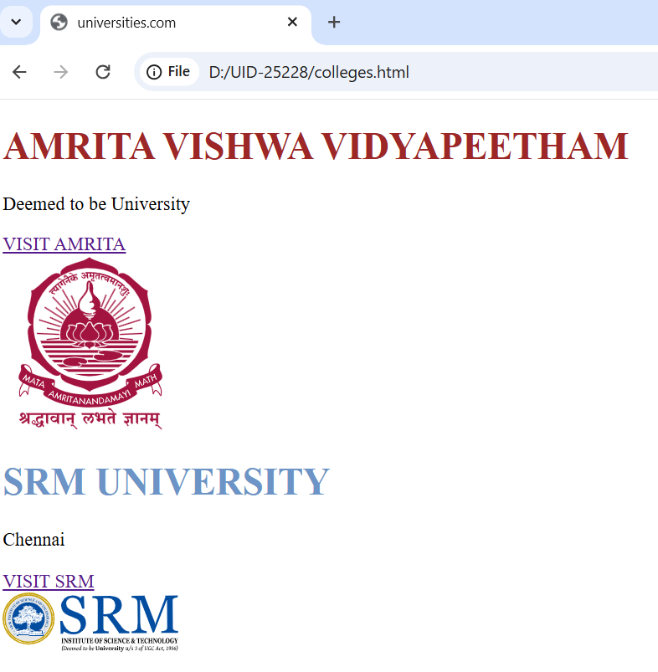

EXPLANATION OF THE TAGS:
• <br>: The HTML <br> element defines a line break. it is an empty tag with no end tag.
• Style: The HTML style attribute is used to add styles to an element such as color, font, size and more.
• <img>: The <img> tag is a fundamental HTML element used to embed an image into a web page
• <a>: The <a> tag, which stands for “anchor”, is used to define a hyperlink.

WEEK2
1.AIM: TO Create the class time table using HTML elements
CODE:
<html>
<table border="1px" widith="420" style="text-align: center;"cellpading="0"cellpading="0">
<th colspan="12" style= "text-align:center;">Master Time Table AIE II Semester C Section</th>
<tr>
<td colspan="6">AI DEPT</td>
<td colspan="8" rowspan="3">venue-612</td>
</tr>
<tr>
<td colspan="6">AIE-C</td>
</tr>
<tr>
<td colspan="6">SEM=2</td>
</tr>
<tr>
<td colspan="6">Class Advisors: <br>
1.Name:Mrs. Kolluru Venkata Anusha <br>
Email : kv_anusha@av.amrita.edu <br>
Mobile Number : +91-9951615749</td>
<td colspan="6">2. Name: Dr.Culala Rajasekharaudayar Kesavulu <br>
Email :cr_kesavulu@av.amrita.edu <br>
Mobile Number : +91-9885248868 <br>
</td>
</tr>
<tr>
<td rowspan="2">TIME/DAY</td>
<td>slot1</td>
<td>slot2</td>
<td rowspan="2">10:35 to 10:45</td>
<td>slot3</td>
<td>slot4</td>
<td>slot5</td>
<td rowspan="2">1.15pm-02.05pm</td>
<td>slot6</td>
<td rowspan="2">3.00pm-3.10pm</td>
<td>slot7</td>
<td>slot8</td>
</tr>
<tr>
<td>08.55-09.45am</td>
<td>09.45-10.35am</td>
<td>10.45-11.35am</td>
<td>11.35am-12.25pm</td>
<td>12.25am-01.15pm</td>
<td>02.10-03.00pm</td>
<td>03.10-04.00pm</td>
<td>04.00-04.50pm</td>
</tr>
<tr>
<td>Monday </td>
<td>22AIE114 Introduction to
Electrical and Electronics
Engineering </td>
<td>22AIE111 Object Oriented
Programming in Java</td>
<td rowspan="5" style="background-color: yellow; color:black;transform: rotate(-180deg); writing-mode: vertical-rl; "><b>SHORT BREAK</b></td>
<td colspan="3">2AIE112 Data
Structures &
algorithm 1_Lab </td>
<td rowspan="5" style="background-color: yellow; color:black;transform: rotate(-180deg); writing-mode: vertical-rl; "><b>LUNCH</b></td>
<td>22AIE113Elements of
Computing Systems - 2 </td>
<td rowspan="5" style="background-color: yellow; color:black;transform: rotate(-180deg); writing-mode: vertical-rl; "><b>SHORT BREAK</b></td>
<td>COUNSELLING </td>
<td> SPORTS</td>
</tr>
<tr>
<td> Tuesday</td>
<td>22AIE115 User Interface
Design </td>
<td>22ADM111 Glimpses of
Glorious India </td>
<td>22AIE111 Object
Oriented
Programming in Java </td>
<td>22AIE114
Introduction to
Electrical and
Electronics
Engineering </td>
<td>22MAT122
Mathematics for
Computing 2(T) </td>
<td>22AIE111Object
Oriented
Programming in
Java-LAB BYOD</td>
</td>
<td colspan="2">22AIE111 Object Oriented Programming in
Java-LAB_3 </td>
</tr>
<tr>
<td>Wednesday</td>
<td>22ADM111 Glimpses of
Glorious India </td>
<td> 22AIE111Object Oriented
Programming in Java(T)</td>
<td colspan="3">22AIE113Elements of Computing Systems - 2 - Lab</td>
<td>
22AIE115 UserInterface Design_lab</td>
<td colspan="2">
22AIE115 UserInterface Design_lab</td>
</tr>
<tr>
<td>Thursday </td>
<td>22MAT122 Mathematics forComputing 2</td>
<td> 22AIE115_User InterfaceDesign</td>
<td colspan="2"> 22AIE114 Introduction to Electrical and
Electronics Engineering Lab B1</td>
<td> 22AIE112_DataStructures &Algorithms 1</td>
<td>22MAT122Mathematics forComputing 2_lab</td>
<td colspan="2">22MAT122Mathematics forComputing 2_lab</td>
</tr>
<tr>
<td> Friday</td>
<td>22AIE113 Elements ofComputing Systems - 2</td>
<td>22MAT122 Mathematicsfor Computing 2</td>
<td colspan="2"> 22AIE112_DataStructures &Algorithms 1</td>
<td>COUNSELLING</td>
<td>22AIE114Introduction toElectrical andElectronicsEngineering LabB2</td>
<td>22AIE114Introduction toElectrical andElectronicsEngineering Lab B2
<td>Library </td>
</tr>
OUTPUT:
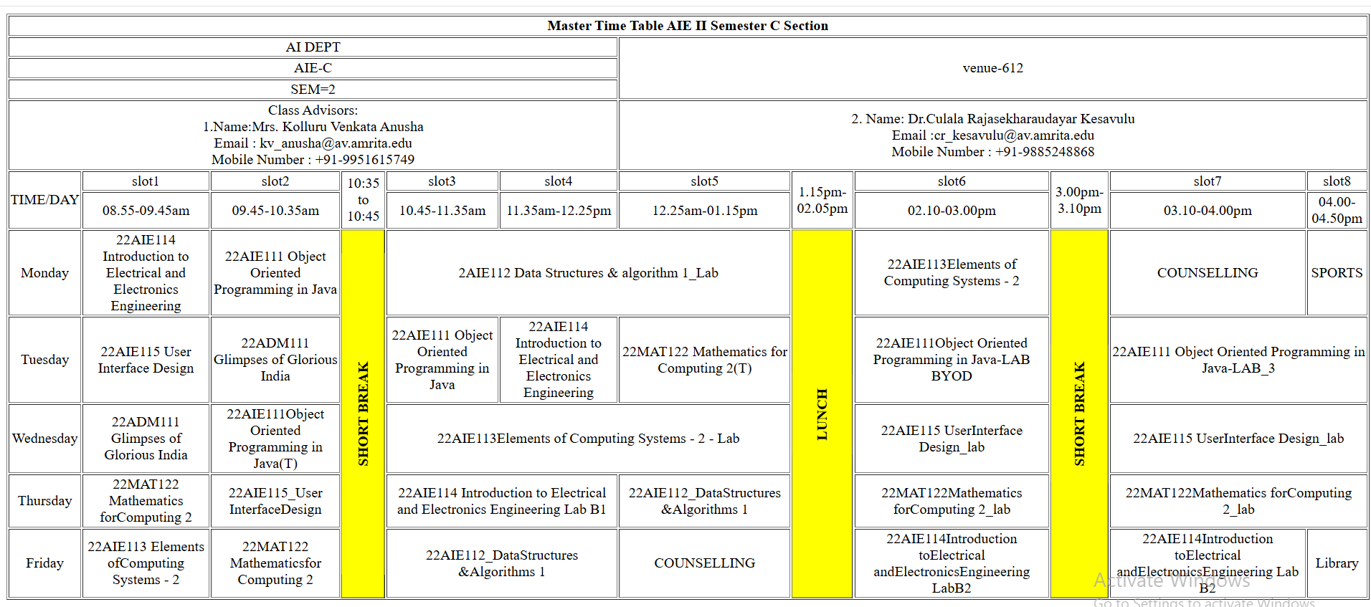

2. AIM: TO Create an HTML webpage that should display syllabus of
all subjects of an image format also time table
CODE:
<!DOCTYPE html>
<html>
<head>
<title></title>
</head>
<BOdy>
<img src="MAT SYLLABUS.jpg" alt="">
<img src="SYLLABUS 2.jpg" alt="">
<img src="SYLLABUS3.jpg" alt="">
<img src="SYLLABUS4.jpg" alt="">
<img src="SYLLABUS.jpg" alt="">
</BOdy>
</html>
</html>
OUTPUT:
